**Vons** usually has all of this and the best apples. I usually only get Fuji or Gala since they are the best.

**Apples**

* 3 Fuji Apples
* 3 Gala Apples
* 1 Green Apple

**Apple Sauce**

* 2 total apple sauces, I think I normally get one treetop and one Safeway Brand (Signature Select no sugar added) If you can’t find the Safeway brand the 2 treetops work great!

2 Treetop no sugar added

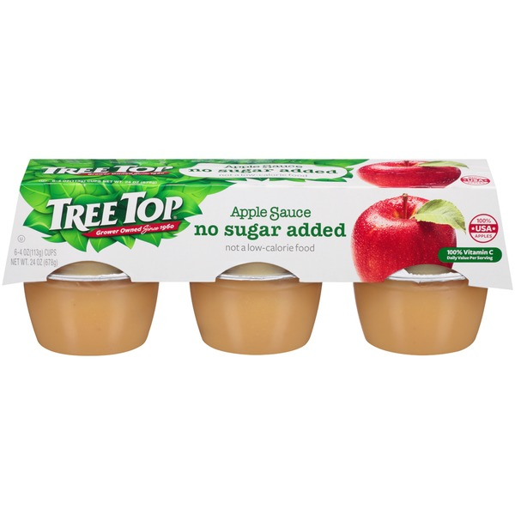

**5 Crystal Geyser Water (1 Gallon Bottle)**

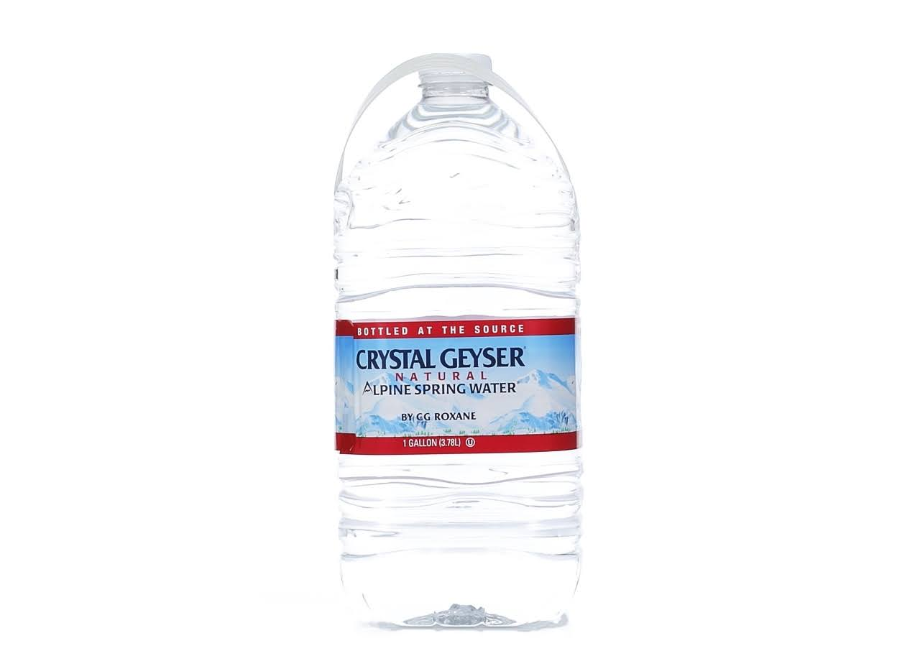

**6 Yoplait Low Fat Strawberry Yogurt**

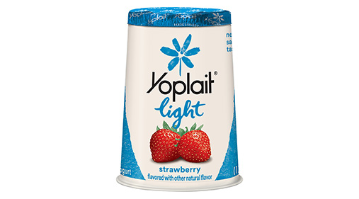

**I think you got these already**

**Wheat Thins Original**

